Label
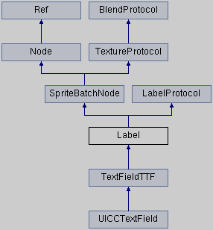
@warning Not support font name.要指定具体的文件名

// TTF字体 (.ttf)
1 static Label * createWithTTF(const std::string& text, const std::string& fontFile, float fontSize, const Size& dimensions = Size::ZERO, TextHAlignment hAlignment = TextHAlignment::LEFT, TextVAlignment vAlignment = TextVAlignment::TOP);
2 static Label* createWithTTF(const TTFConfig& ttfConfig, const std::string& text, TextHAlignment alignment = TextHAlignment::LEFT, int maxLineWidth = 0);

// BMFont字体 (.fnt和.png)
static Label* createWithBMFont(const std::string& bmfontFilePath, const std::string& text, const TextHAlignment& alignment = TextHAlignment::LEFT, int maxLineWidth = 0, const Vec2& imageOffset = Vec2::ZERO);

// @warning It is as expensive as changing the string if you haven't set up TTF/BMFont/CharMap for the label.如果你没有为Label设置TTF/BMFont/CharMap，会产生很大的开销
virtual void setString(const std::string& text) override;
【沿袭了C语言的转义字符， ‘\n’换行】

// 获得下标为 letterIndex 的字体Sprite 【该Node已在渲染树中】
virtual Sprite * getLetter(int letterIndex);

